JURONG BIRD PARK
J
urong Bird Park (Chinese: 裕廊飞禽公园; Malay: Taman Burung Jurong; Tamil: ஜுரோங் பறவை பூங்கா), is a tourist attraction in Singapore managed by Wildlife Reserves Singapore. It is a landscaped park, built on the western slope ofJurong Hill. It is located within the Boon Lay Planning Area of the Jurong district and has an area of 202,000 square metres (50 acres).
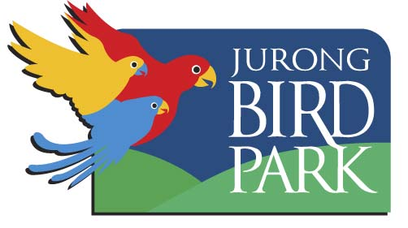
The idea of a permanent bird exhibit was first conceived by late Dr Goh Keng Swee, then Minister for Finance, in 1968. During a World Bank Meeting in Rio de Janeiro, Dr Goh visited its zoological garden and was impressed with its free-flightaviary. He sought to see that Jurong would be more than an industrial zone that Singaporeans would have a place where they could escape from urban life, where people could relax with nature. On 3 January 1971, Jurong Bird Park, built at a cost of S$3.5 million, was opened to the public.
Jurong Bird Park is now a world-famous bird zoo where there are specimens of magnificent bird life from around the world, including a large flock of flamingos. It is currently the world's largest bird park in terms of number of birds, and second largest both in number of bird species and land area (after Germany's Weltvogelpark Walsrode). There are 5,000 birds of 380 species in Jurong Bird Park. Of these, 29 are of threatened species.^{[1]}

In 2006, Jurong Bird Park completed its S$10-million makeover. With the upgrading, the park now boasts a new entrance plaza, a park-owned and managed Bongo Burgers restaurant, a Ben & Jerry's ice cream parlour, a gift shop and a bird hospital.^{[2]}

Source: http://en.wikipedia.org/wiki/Jurong_Bird_Park

